**Name: Chernor Usman Tuary**

**ID: 32717**

**School: of Technology**

**Course: BSc Hons Computer Science**

**Year: 4**

**Module: Web and internet Technology –**

**Comps 461**

**Lecturer: MR M. Vibbie**

**Web Project Name: Drugs Management System**

**INTRODUCTION**

The project takes records on Medical Dosage and Notification in a hospital or drugs store system. It is design for hospital and clinic in our area in order to manage all the records of every users of the system in the clinic or hospital. The system will enable the user to store medicine as well as give user notification on when to take the next dosage of medication on daily or monthly basses of patience and how the drugs transaction is running in the medical system.

**OBJCTIVES**

The main object is to monitor and control how drugs are use in and out of the medical system.

**SCOPE**

This application can be used by any other clinic, hospital or pharmacy to minimize the use of hard copy files system, this application is effective, user friendly and outpatient can also use the application at home to store the medicine given to them and set timely notification for every other dose.

**BACKEND AND FRONTEND APPLICATION USE**

The system is created using html, css, php, bootstraps, usbserver, database, javascript. Mysql

**THE INDEX FIRST PAGE**

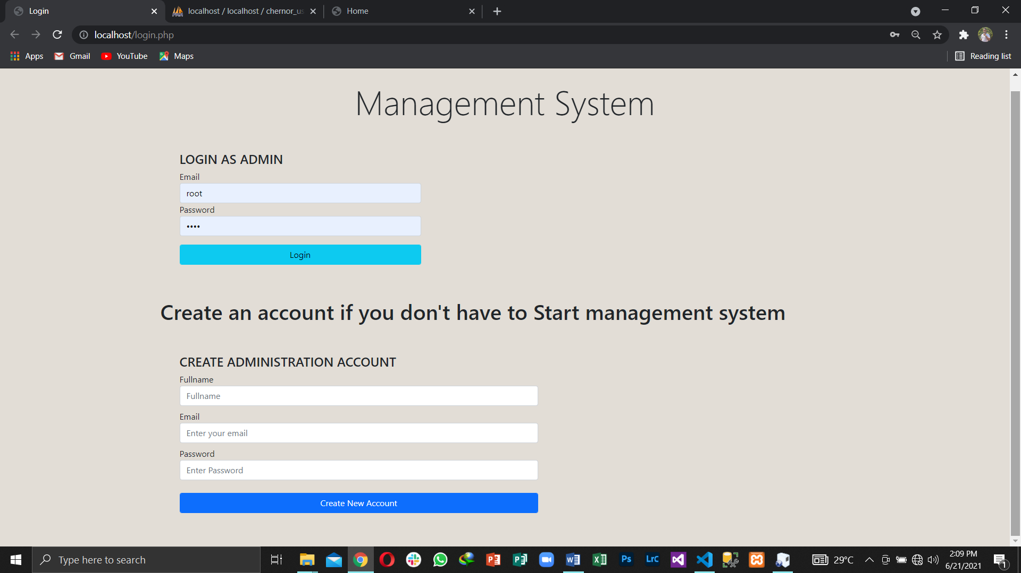

After extracting the `project` folder to desired destination

Enter the login credentials for phpmyadmin default username=root and password=usbw, then log in to your mysql database, after successfull login create a new database but I have already created an account with email: [tchernoroturay@yahoo.com](mailto:tchernoroturay@yahoo.com) and password: snizzytee to log in as admin.

So after the admin log in before it will take you to the next main page.

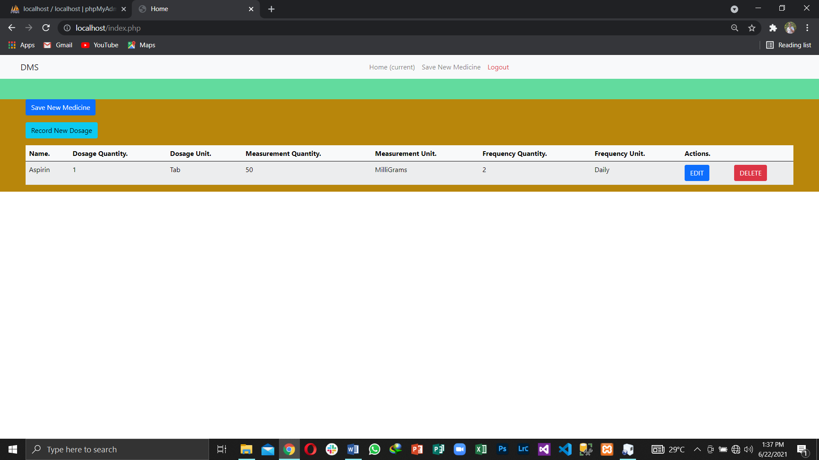

This main page comprises of save new medicine that enable user to enter new records of drugs and save it. And this image below is to create new medicine interface.

Which consist of

* Medicine name
* Dosage quantity
* Dosage unit
* Milligrams
* Unit(g/mg)
* Frequency Quantity
* Frequency Unit

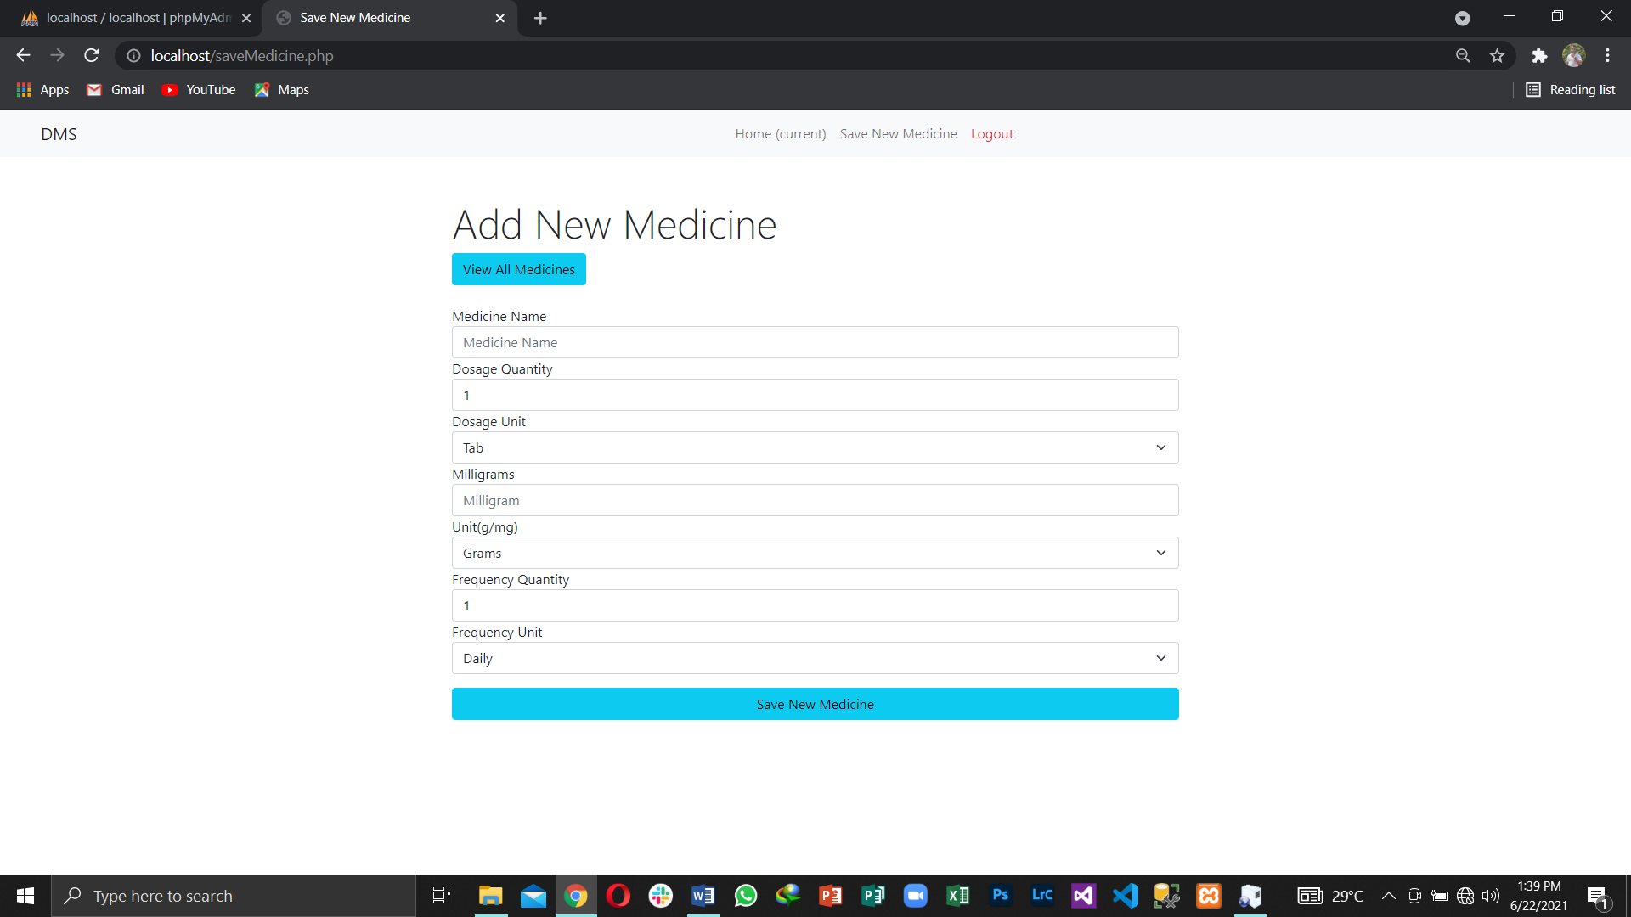

*And the second bottom is the Dosage record

Which takes records of the drugs been taking out of the drugs store.

Below is the interface of the Dosage record.

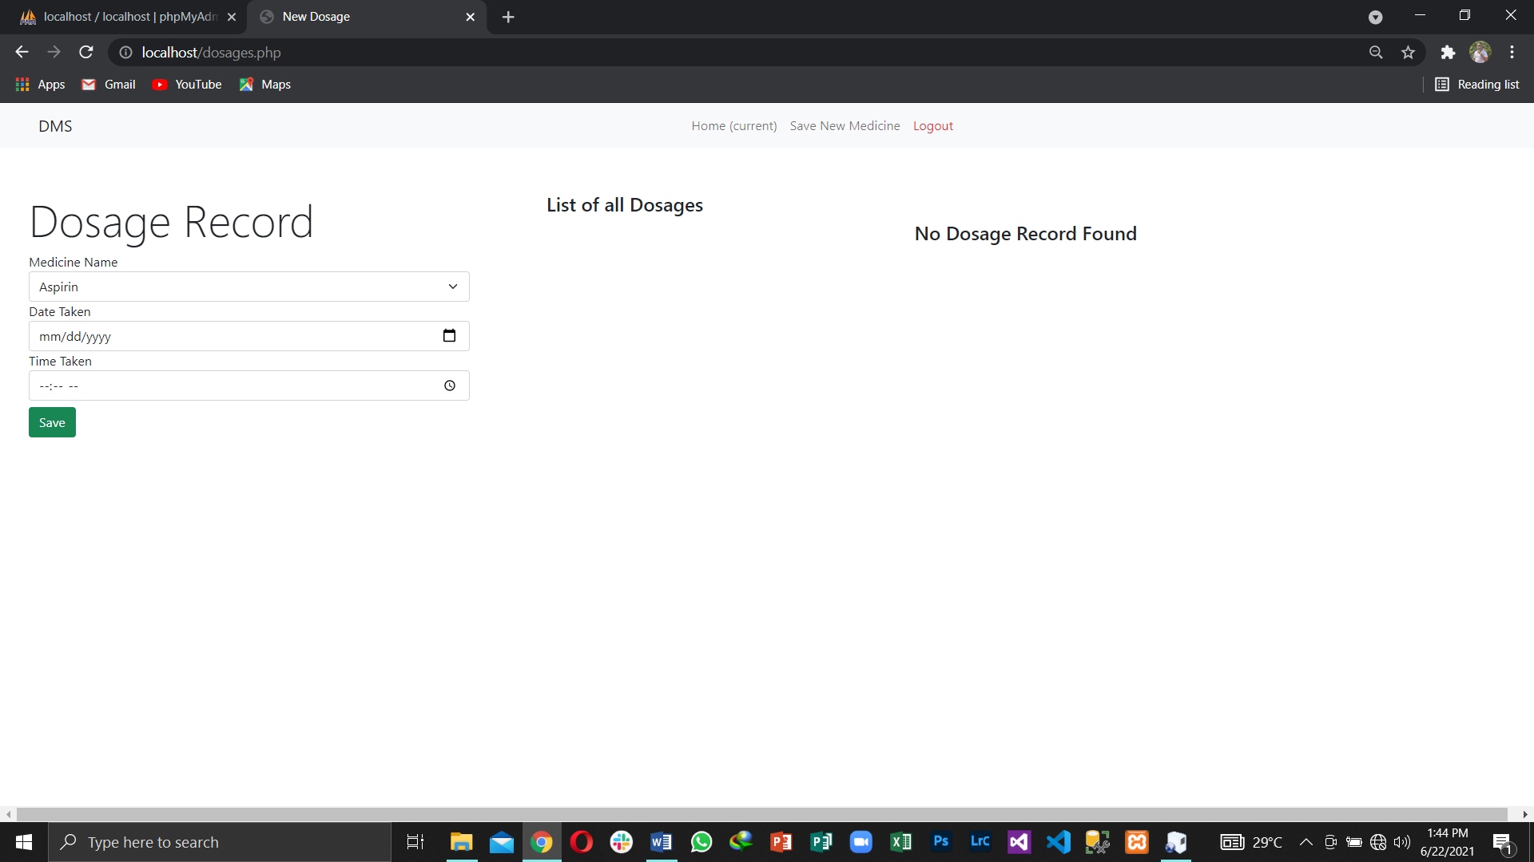

The main page can also edit save records and delete them also as instructed and also logout bottom that allow the administrator to logout after been carry out register records exercises in the system. And can login with the same email and password use to create the account with.

**DATA FLOW DIAGRAM**

Login

*Username

*Password

User Registration

*User name

*Email

*password

SQL

db

Log Out

Add and save new medicine

Medicine

Save Dosage

Notification

Display Result

Edit or Delete

Display in the save records page.

SQL db

SQL db